**Changes**

**Initial land on website**

* Re-added a button to the image

We want the button to have UX properties, similar to that of the button found on the picture part of <https://designcode.io>

We want a hover feature where the outside of the little circle moves

**Lets Get Started (section 3)**

* Changing the cards to glass morphism
* You will notice there is no background to this section and the cards don’t look nice
* The first card is the example not hovered over and the send and third are the example when the mouse is hovered over it
* **We would like developer input here**

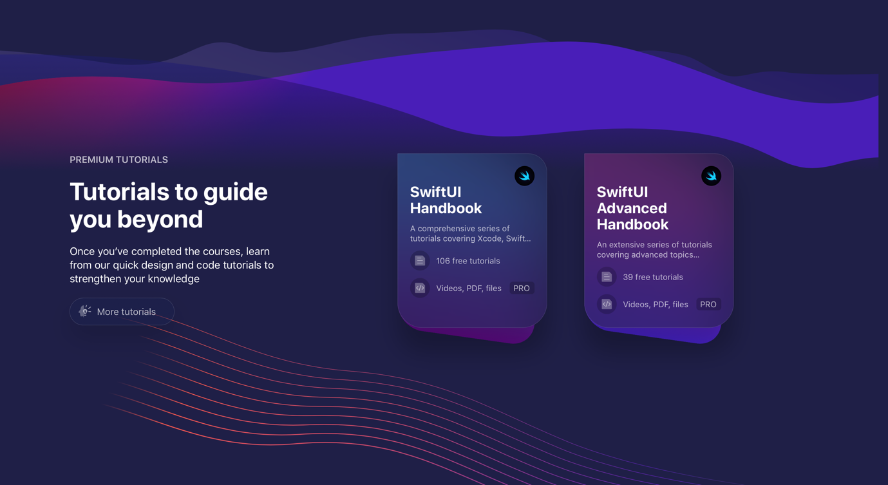<https://designcode.io> scroll down to the “Tutorials to guide you beyond” section of their website

We would love developers to create a slightly contrasting background to pop the glass cards a bit more as it isn’t recommended to have them on a singular colour background

**Removed the apply our tips section (Replaced)**

**Added: A premium education summary with scroll feature**

* We want to remove the third of the text/images “Apply our tips to the promotions”

We have created a section where the user can see the course outline for free on the landing page but obviously won’t be able to access it unless paid

UX:

* User can scroll down the side to see that entire course section
* There two big colourful boxes within the divs are buttons to the subscription page

Notes:   
This part is more relevant when we give you the course its properties, this can be filled with anything for the moment

**Testimonials changed to glassmorphism**

* We have changed the testimonial cards to glassmorphism with a contrasting background like most UI manuals tell you to with this style UI
* It looks a little bit rough at the moment, obviously any developer feedback would be very helpful

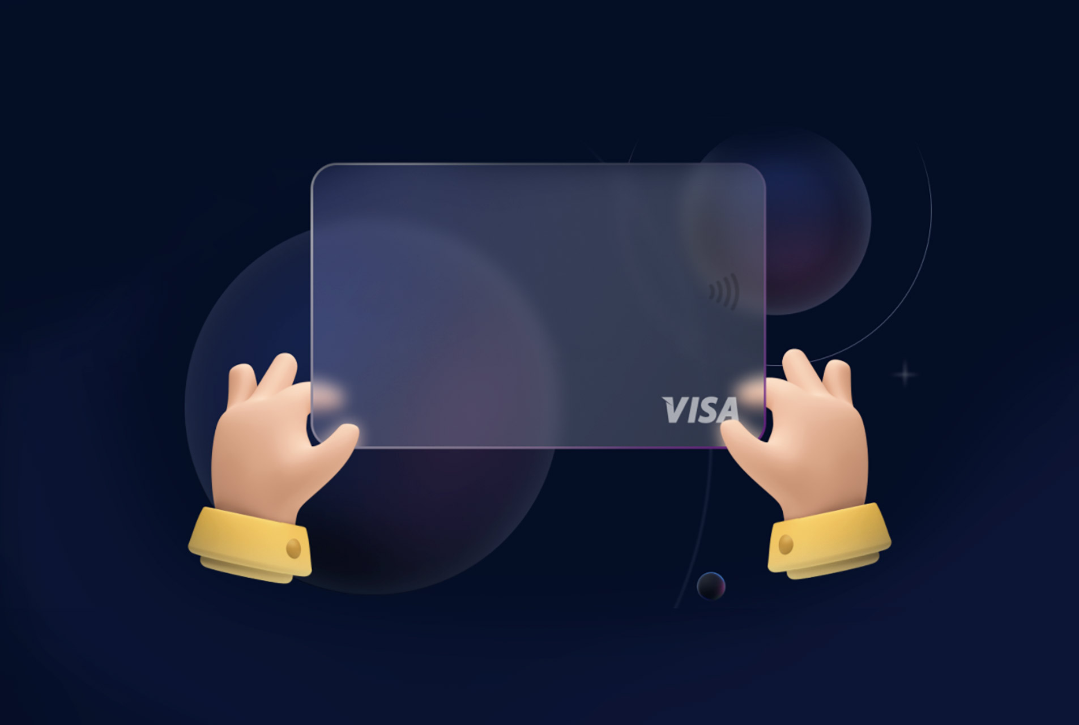

* Our UI/UX guy said if the devs have any experience implementing hands holding the testimonial cards similar to this then attempt to do it, however, if this is not something they have done or can do. Don’t worry about it